EP208 Additional Document

Calculating the speed and the acceleration of a dron

Time vs Position data of a dron moving upward direction is collected as follows:
Time(s) Position(m)  t y(t)  ------- -----------  0.0 0.00  0.1 0.47  0.2 1.32  0.3 2.38  0.4 3.57  0.5 4.82  0.6 6.07  0.7 7.26  0.8 8.34  0.9 9.26  1.0 9.97  1.2 10.46  1.3 10.67 | 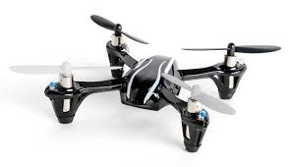
Compute speed and acceleration of the dron at t = 0.9 s.

