EP208 Additional Document

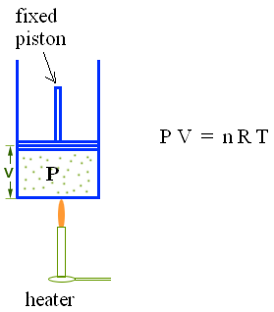
Curve Fitting

Consider a heated gas in a fixed volume.
The following data (stored in file TP.txt) contains
the temperature (T) in ºC and the pressure (P) in hPa
of the gas.

Find the temperature in ºC where the gas pressure
is zero.

T(ºC) P(hPa)
------- ------
0 1012
5 1021
10 1038
15 1065
20 1091
25 1111
30 1116
35 1133
40 1165
45 1171
50 1198
55 1223
60 1235
65 1258
70 1259
75 1280
