|  |  |  |
| --- | --- | --- |
| **EXAMPLE NUMERICAL DERIVATIVE**  Figure shows a free falling object under the influence of gravity (g) on Earth. Time vs position data of the object is acquired to measure the value of g. Find the speed of the object at t = 0.2 s and g. |  | **Time Height**  **t (s) y (m)**  0.0667 1.1816  0.1001 1.1776  0.1335 1.1462  0.1668 1.1207  0.2002 1.0723  0.2336 1.0193  0.2669 0.9401  0.3003 0.8583  0.3337 0.7624  0.3670 0.6547  0.4004 0.5446  0.4338 0.4222  0.4671 0.2943  0.5005 0.1665 |

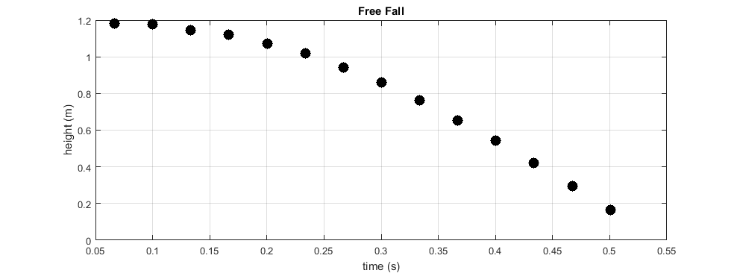

|  |  |  |
| --- | --- | --- |
| **EXAMPLE NUMERICAL DERIVATIVE**  Figure shows a free falling object under the influence of gravity (g) on Earth. Time vs position data of the object is acquired to measure the value of g. Find the speed of the object at t = 0.2 s and g. |  | **Time Height**  **t (s) y (m)**  0.0667 1.1816  0.1001 1.1776  0.1335 1.1462  0.1668 1.1207  0.2002 1.0723  0.2336 1.0193  0.2669 0.9401  0.3003 0.8583  0.3337 0.7624  0.3670 0.6547  0.4004 0.5446  0.4338 0.4222  0.4671 0.2943  0.5005 0.1665 |



|  |  |  |  |
| --- | --- | --- | --- |
| **EP208 CHAPTER 3: EXAMPLE ROOT FINDING PROBLEM**  The following formula gives the upward velocity (v) of a rocket as a function of time (*t*):  *t* = time in seconds  *u* = velocity of the fuel expelled relative to the rocket = 950 m/s  *m* = initial mass of the rocket (at *t* = 0) = 2 x 105 kg  *g* = gravitational acceleration = 9.8 m/s2  *q* = fuel consumption rate = 3000 kg/s  **(a) Plot *t* vs v graph of the rocket and estimate time *t* graphically.**  **(b) Find the time taken by the rocket to attain the velocity of 450 m/s.** | |  | |
| **EXERCISES**  **1. Using Newton-Raphson method, find the real root of the following functions with accuracy at least 1%**  a)  b)  c)  d)  **2. Using Newton-Raphson method to compute the following values with an accuracy of 10**–**4**  a)  b) | **3. Using Newton-Raphson method, find the complex root of the following functions with with an accuracy of 10**–**6**  a) start with x0 = 1 + 2*i*  b) start with x0 = 1 – *i*  **4. Find the roots of following functions:**  a)  start with (x0, y0) = (1.5, 3.5)  b)  start with (x0, y0) = (3.4, 2.2) | |

- - - - - - - - - - - - - - - - - - - - - - - - - - - - - - - - - - - - - - - - - - - - - - - - - - - - - - - - - - - - - - - - - - - - - - - - - - - - - - - - - -

|  |  |  |  |  |
| --- | --- | --- | --- | --- |
| **EP208 CHAPTER 3: EXAMPLE ROOT FINDING PROBLEM**  The following formula gives the upward velocity (v) of a rocket as a function of time (*t*):  *t* = time in seconds  *u* = velocity of the fuel expelled relative to the rocket = 950 m/s  *m* = initial mass of the rocket (at *t* = 0) = 2 x 105 kg  *g* = gravitational acceleration = 9.8 m/s2  *q* = fuel consumption rate = 3000 kg/s  **(a) Plot *t* vs v graph of the rocket and estimate time *t* graphically.**  **(b) Find the time taken by the rocket to attain the velocity of 300 m/s.** | |  | | |
| **EXERCISES**  **1. Using Newton-Raphson method, find the real root of the following functions with accuracy at least 1%**  a)  b)  c)  d)  **2. Using Newton-Raphson method to compute the following values with an accuracy of 10**–**4**  a)  b) | **3. Using Newton-Raphson method, find the complex root of the following functions with with an accuracy of 10**–**6**  a) start with x0 = 1 + 2*i*  b) start with x0 = 1 – *i*  **4. Find the roots of following functions:**  a)  start with (x0, y0) = (1.5, 3.5)  b)  start with (x0, y0) = (3.4, 2.2) | | |
| **EP208 CHAPTER 4: EXAMPLE OPTIMIZATION PROBLEMS**  **CASE STUDY 1**  Consider a cylindrical container having walls of negligible thickness as shown in the figure. The container is to hold *V* = 2 m3 waste water. The material and the welding costs used for constructing the container are 100 TL/m2 and 20 TL/m respectively. The aim is to design the container so that the total cost is minimized.  (a) Write down the total cost function, *C*(*r*), as a function of radius *r*.  (b) By using the modified Newton-Raphson iterative formula, write a C++ program to find the minimum value of the total cost function to an accuracy at least 6 decimal places. Your program should output the evolution of *r*, *h* and *C*(*r*) at each iteration.  (c) Use fminsearch() function in MATLAB for the case (b).  **CASE STUDY 2**  The figure shows the cross section of channel carrying water. Determine *h*, *b* and *θ* that minimize the length of the wetted perimeter while maintaining a cross-sectional area of  6 m2. (Minimizing the wetted perimeter results in least resistance to the flow) | | | *r*  *h* | |
| **EXERCISES**  **1.** Using Plank’s formula for a black-body radiator,  derive Wein law:  **2.** Use fminsearch()function to locate the minimum of the function:  f(x, y, z) = (x‒10)2 + (y ‒ 4)2 + (z ‒ 0.9)2 + 3(1 ‒ xyz)2  Start with: (x0 , y0 , z0) = (5, 5, 5).  **3.** Using fminsearch() function, find the maximum of the following function:  f(x, y, z) = −2x2 − 3y2 − z2 + xy + xz − 2y  and confirm the result analytically. | |  |  | | --- | --- | | **4.** A window is being built and the bottom is a rectangle and the top is a semicircle as shown in the figure. There is framing materials whose side is *L*. The obtain the dimensions of the window in order to let in the most (optimum) light. Write a C++ program to input value of *L* and output optimum values of *h* and *r*. |  | | | |

- - - - - - - - - - - - - - - - - - - - - - - - - - - - - - - - - - - - - - - - - - - - - - - - - - - - - - - - - - - - - - - - - - - - - - - - - - - - - - - - - -

|  |  |  |  |
| --- | --- | --- | --- |
| **EP208 CHAPTER 4: EXAMPLE OPTIMIZATION PROBLEMS**  **CASE STUDY 1**  Consider a cylindrical container having walls of negligible thickness as shown in the figure. The container is to hold *V* = 2 m3 waste water. The material and the welding costs used for constructing the container are 100 TL/m2 and 20 TL/m respectively. The aim is to design the container so that the total cost is minimized.  (a) Write down the total cost function, *C*(*r*), as a function of radius *r*.  (b) By using the modified Newton-Raphson iterative formula, write a C++ program to find the minimum value of the total cost function to an accuracy at least 6 decimal places. Your program should output the evolution of *r*, *h* and *C*(*r*) at each iteration.  (c) Use fminsearch() function in MATLAB for the case (b).  **CASE STUDY 2**  The figure shows the cross section of channel carrying water. Determine *h*, *b* and *θ* that minimize the length of the wetted perimeter while maintaining a cross-sectional area of  6 m2. (Minimizing the wetted perimeter results in least resistance to the flow) | | *r*  *h* | |
| **EXERCISES**  **1.** Using Plank’s formula for a black-body radiator,  derive Wein law:  **2.** Use fminsearch()function to locate the minimum of the function:  f(x, y, z) = (x‒10)2 + (y ‒ 4)2 + (z ‒ 0.9)2 + 3(1 ‒ xyz)2  Start with: (x0 , y0 , z0) = (5, 5, 5).  **3.** Using fminsearch() function, find the maximum of the following function:  f(x, y, z) = −2x2 − 3y2 − z2 + xy + xz − 2y  and confirm the result analytically. | |  |  | | --- | --- | | **4.** A window is being built and the bottom is a rectangle and the top is a semicircle as shown in the figure. There is framing materials whose side is *L*. The obtain the dimensions of the window in order to let in the most (optimum) light. Write a C++ program to input value of *L* and output optimum values of *h* and *r*. |  | | |

**EP208 CHAPTER 5: EXAMPLE NUMERICAL INTEGRATION PROBLEM**

*Computing total amount of wastewater:* The rate of flow of wastewater in an open channel has been measured and the following data (in every 10 min) has been acquired. Determine the total flow in m3 during the first 120 minutes.

|  |  |
| --- | --- |
|  | **Time Flow**  **(min) (m3/min)**  **----- --------**  **0 665**  **10 705**  **20 780**  **30 830**  **40 870**  **50 890**  **60 860**  **70 800**  **80 725**  **90 670**  **100 640**  **110 620**  **120 600**  **EXERCISE**  Equation of an ellipse is given by *x*2/*a*2 + *y*2/*b*2 = 1 where *a* is called the semi-major axis and *b* is semi-minor axis. Write a program to input values of *a* and *b* from keyboard and output the area of the ellipse via numerical integration using trapezoidal and Simpson’s method with *n* = 1000 parts. Compare your results with the analytical result known as *S* = π*ab.*  *.* |

- - - - - - - - - - - - - - - - - - - - - - - - - - - - - - - - - - - - - - - - - - - - - - - - - - - - - - - - - - - - - - - - - - - - - - - - - - - - - - - - - -

**EP208 CHAPTER 5: EXAMPLE NUMERICAL INTEGRATION PROBLEM**

*Computing total amount of wastewater:* The rate of flow of wastewater in an open channel has been measured andthe following data (in every 10 min) has been acquired. Determine the total flow in m3 during the first 120 minutes.

|  |  |
| --- | --- |
|  | **Time Flow**  **(min) (m3/min)**  **----- --------**  **0 665**  **10 705**  **20 780**  **30 830**  **40 870**  **50 890**  **60 860**  **70 800**  **80 725**  **90 670**  **100 640**  **110 620**  **120 600**  **EXERCISE**  Equation of an ellipse is given by *x*2/*a*2 + *y*2/*b*2 = 1 where *a* is called the semi-major axis and *b* is semi-minor axis. Write a program to input values of *a* and *b* from keyboard and output the area of the ellipse via numerical integration using trapezoidal and Simpson’s method with *n* = 1000 parts. Compare your results with the analytical result known as *S* = π*ab.*  *.* |